**assignment 12 – declarative visualization in python – altair**

a)

c)

d)

e) The top 5 states according to the bar chart are:

1. New York

2. California

3. Florida

4. Texas

5. New Jersey

f)

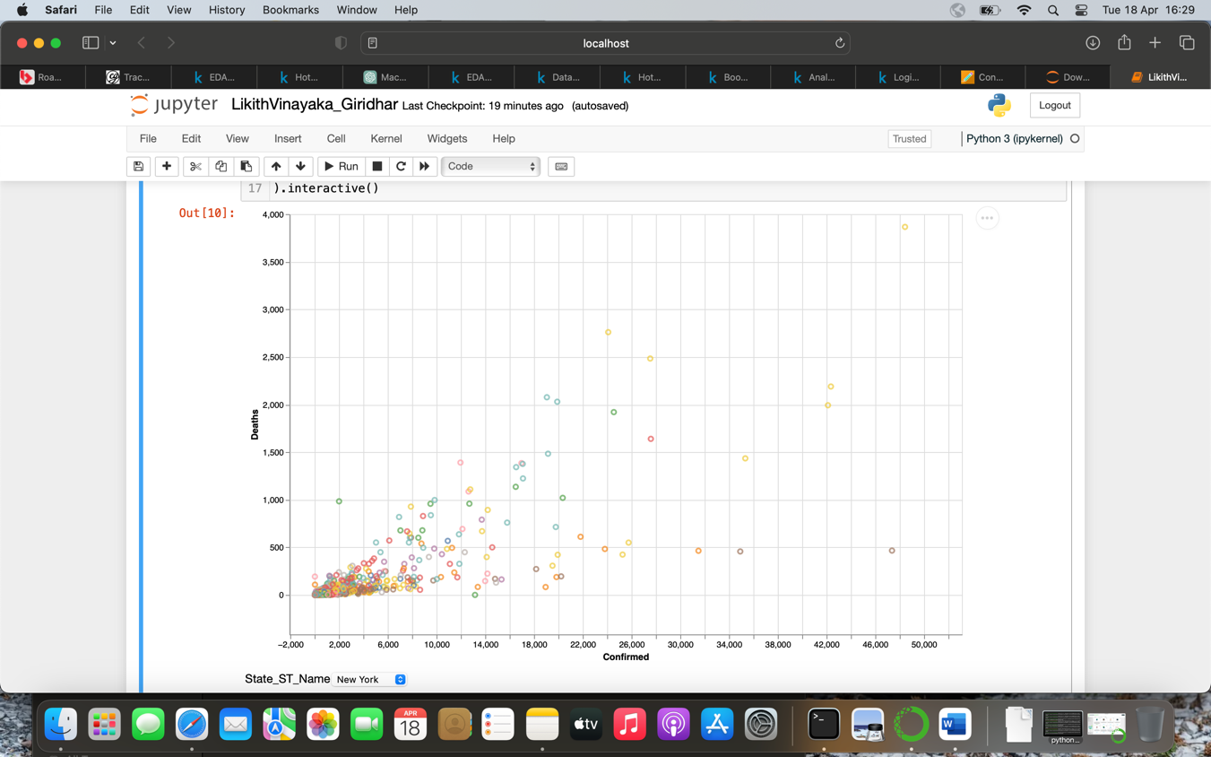

g)

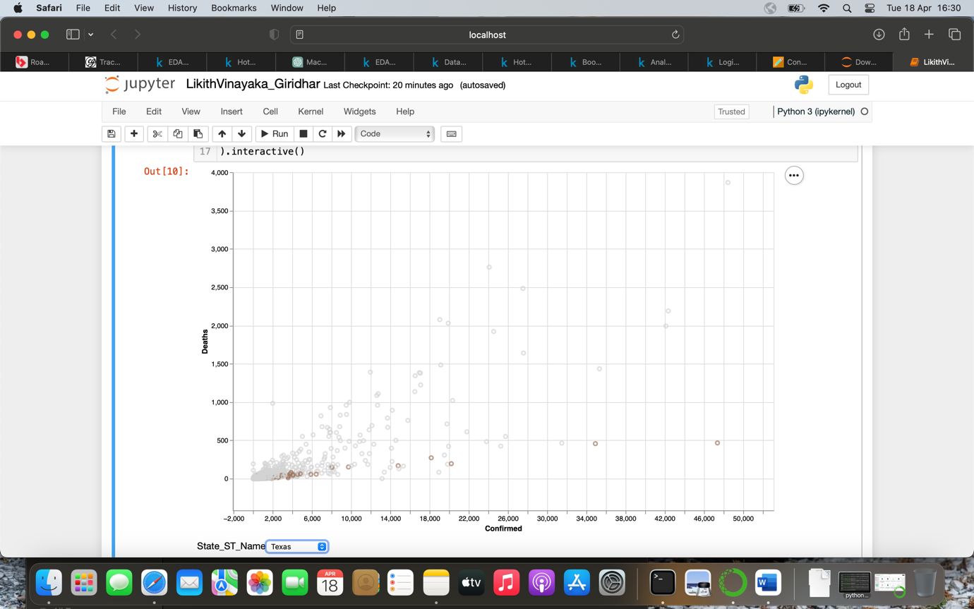

h)

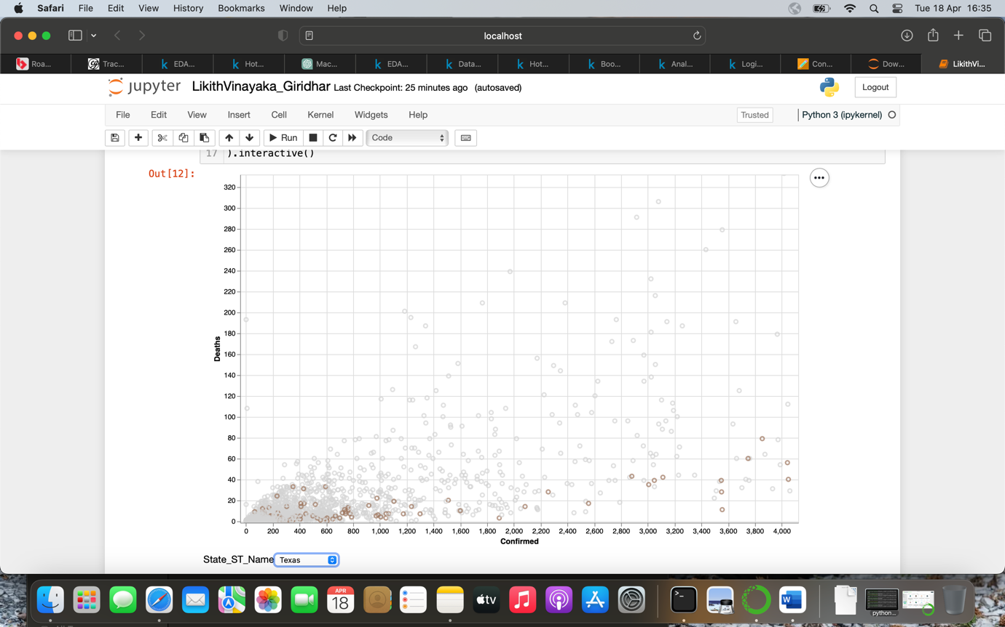

i)

